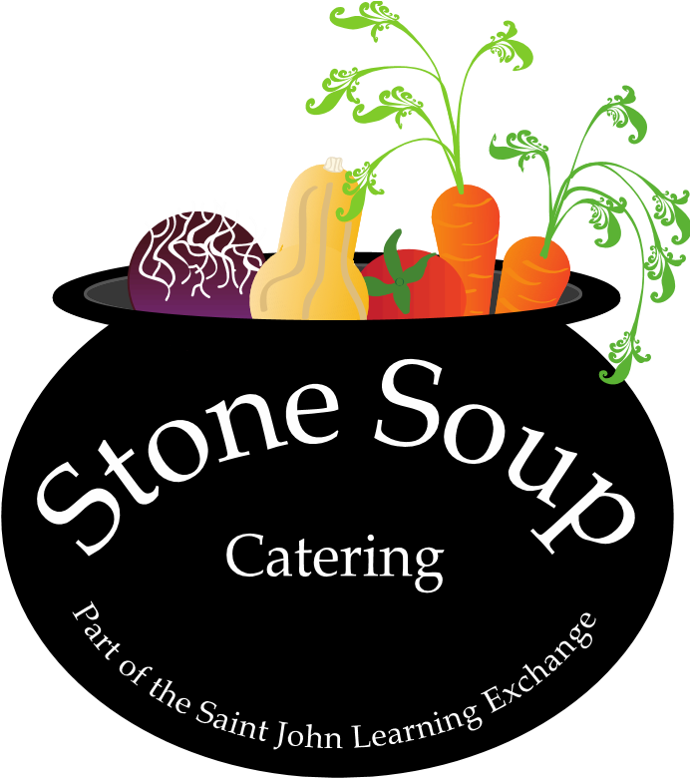
We are looking for Café Staff ( Summer Student)

Stone Soup is a café owned and operated by the Saint John Learning Exchange specializing in wholesome and healthy food and beverage options located in a great community
Are you…
A hard working, responsible, team player with a positive, energetic attitude, who loves working with people.

Do you have…
-A passion for food, coffee, cooking and community
-Works well in a fast pace environment
- Excellent time management and organization skills and the ability to multi task
-Strong communication skills and friendly energetic attitude
-Ability to work a flexible schedule on your feet for several hours and lift heavy items
-Experience is an asset but we are willing to train

Responsibilities Include:
-Barista
-Cashier
-Cooking
-Food Preparation
-Foster a team environment & display professional conduct
-Maintain & organize inventory
-Ensure health & safety standards are maintained
-Multi-task and problem solve

Compensation:
-30hrs hours per week for 8 weeks
-Competitive hourly rate

Please send a resume to StoneSoupSJ@gmail.com

